4379342 - Division Sets Management and Reporting
Division Sets Management and Reporting (Epic 4379342)1. Customer Problemneed to group divisions into hierarchical sets and produce multi-level reports (e.g., Division Set totals and per-division columns).
2. Customer Researchand PDF examples detail Division Sets 1–2, with totals and per-division breakdowns.
3. Our SolutionCreate division sets; allow nesting (sets in sets).
- Reporting UI supports level selection and total calculations for sets.
Dependencies: reporting engine, division taxonomy, UX designer.
4. Product MetricsTime to build multi-level report: -50%.
- Coverage: support 2–3 levels; scale beyond with perf targets.
Appendix: Child Features4379343 Division Set Creation and Hierarchy Configuration
- 4379344 Division Set Setup Interface
- 4379345 Multi-level Financial Reporting
- 4379346 Report Level Selection Controls
- 4379347 Division Set Total Calculations
Appendix: Quick prototypePDF tables showing Division Set totals and per-division columns.
Appendix: LinksHYPERLINK "https://dev.azure.com/tr-tax/TaxProf/_workitems/edit/4379342"Open Epic 4379342

Appendix: Quick prototype
Figure: PDF page 67
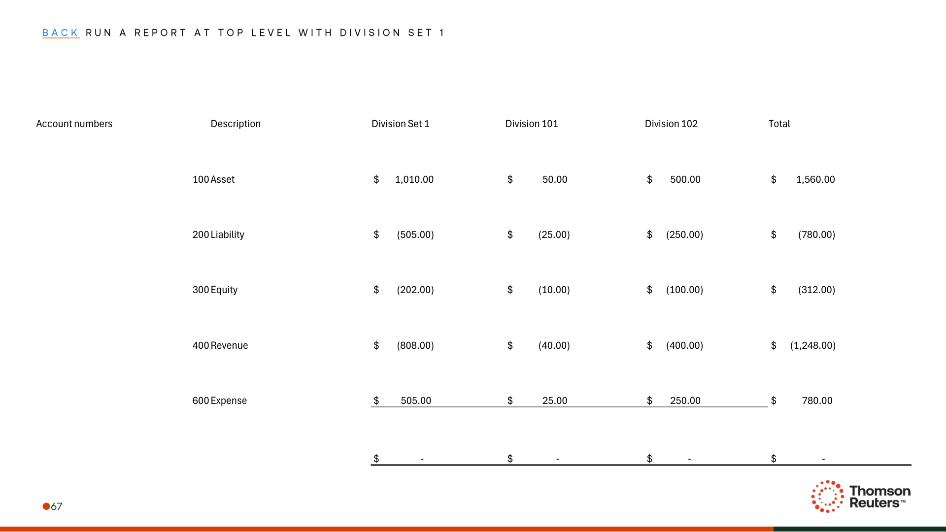
Figure: PDF page 71
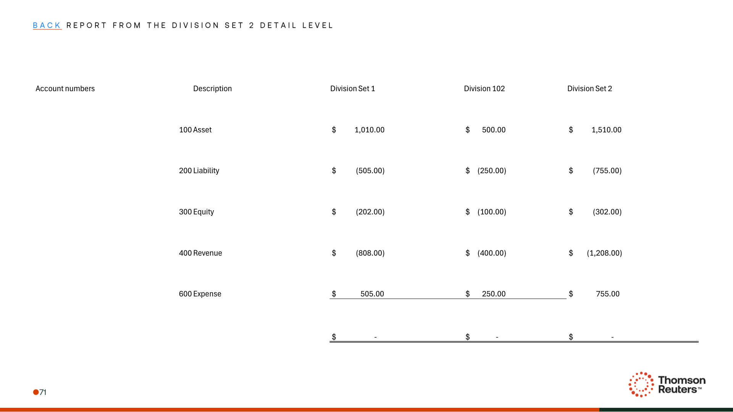
Figure: PDF page 72
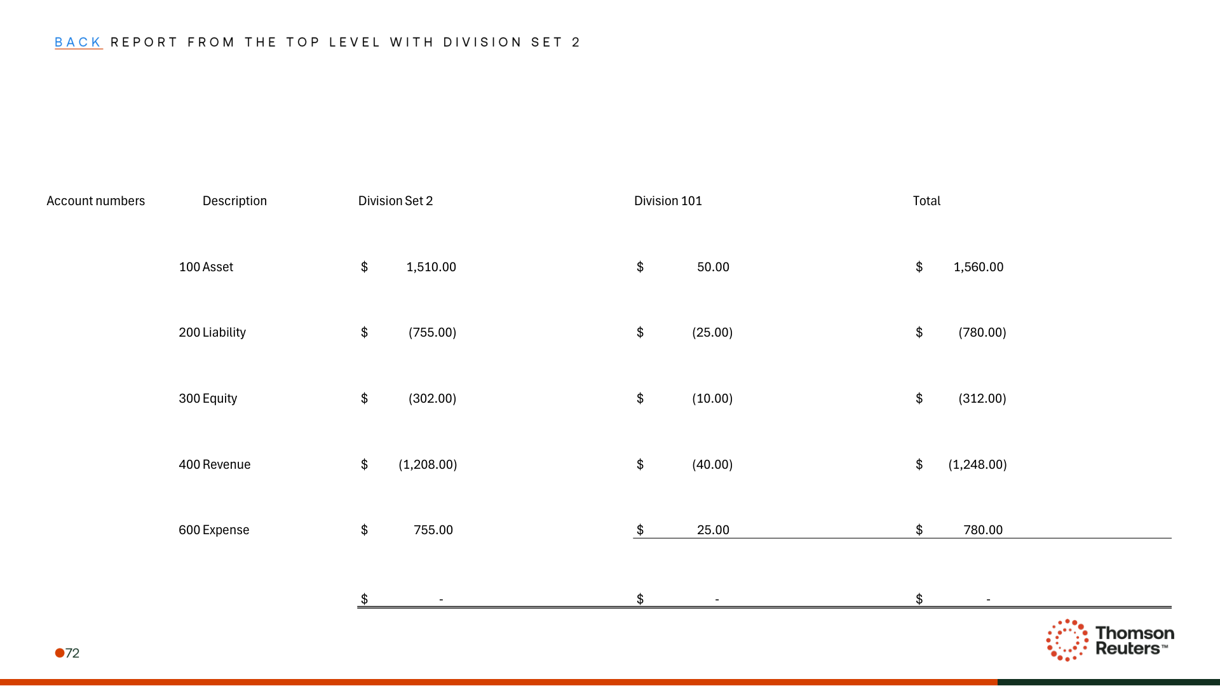

Appendix: Links
ADO Epic Link: https://dev.azure.com/tr-tax/TaxProf/_workitems/edit/4379342

